This is an initial drawing of my Temperature Conver application. This is slightly different than the original product. It does not include buttons between each section and another label that shows the output from the text box convert button.

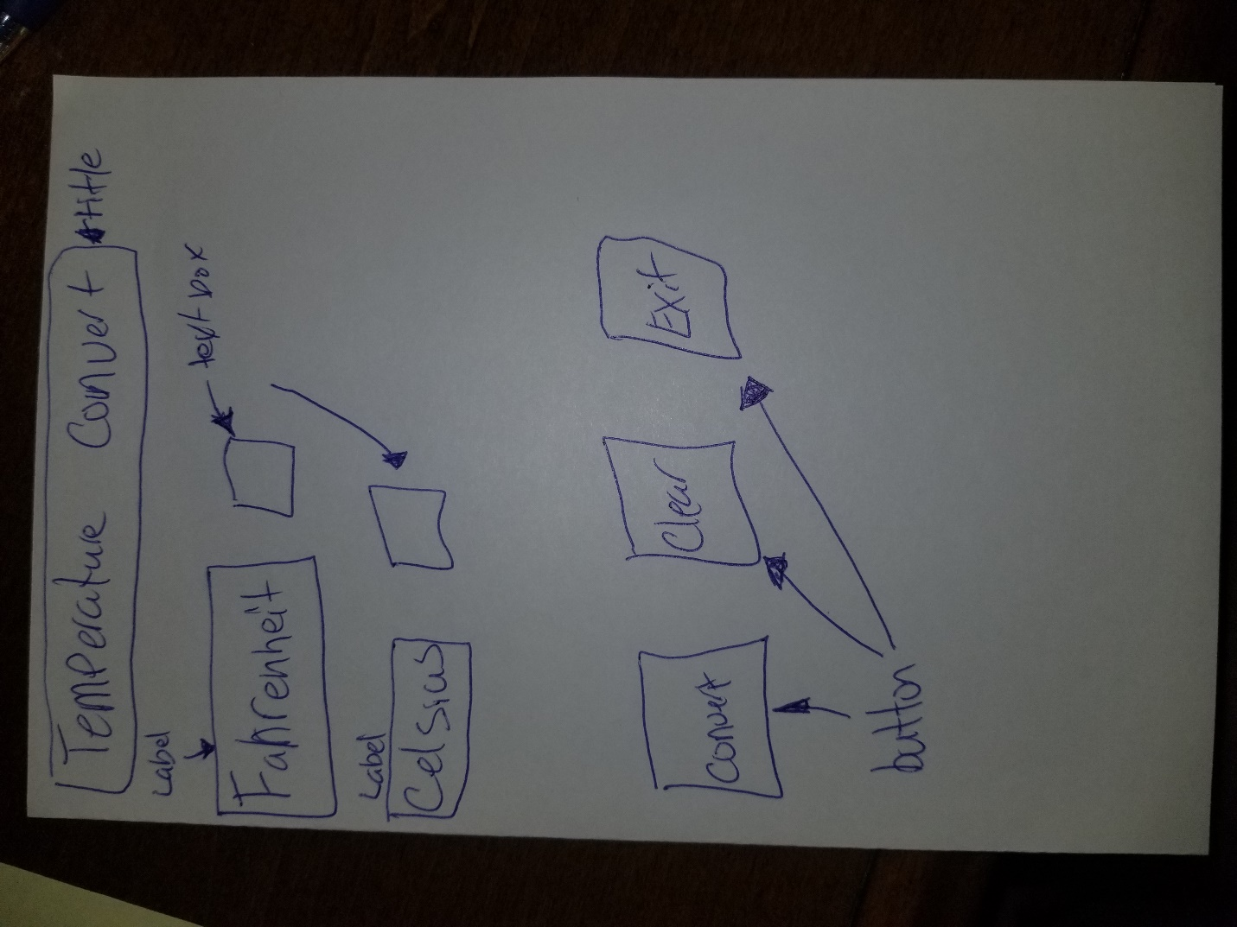

Final product of the application. When I created the application, I had an extra space on the right, so I assumed that you would get a good chuckle out of that. I could have made the application a lot smaller or spread things out, but the over all flow did not set well with me when I attempted that.

In the final product there are several customizations in the application, such as the background, the gif, the border type, the fact the application can not be resized, and other small fine details. I hope you enjoy it was fun to work on this application.

